# NGAPS+ NASA Email Signature, Preferred Name, Pronouns, and Bio Edit Guide

# *This document was last updated 15 April 2025*

# Why have a detailed signature or NASA bio page?

Having some key information in your email signature and on your NASA bio page allows others to quickly learn who you are and what you do at NASA. You can even think of your NASA bio page as a public CV. It also serves as the primary tool that NASA management utilizes to learn more about what you are working on. Read further to learn how to create an email signature on Outlook and edit your NASA bio page.

## Outlook Email Signature

How to make or edit an Outlook Signature:

* Windows: Open of Microsoft Outlook (the images below are for the desktop app, but the web app should work similarly) and start a new email. Click on the “signatures” drop down (red box in the image above) and then click “Edit Signatures”

* Mac: In the top toolbar, click on “Outlook” and “Settings…”

* Then click on “Signatures”

* This will get you to an editor that looks like this:

* You can make your signature by hitting the “+” symbol and then “Edit”. A new window will pop open which will allow you to craft a message that has links or even images (though images are usually not recommended as some people’s browsers may not display them correctly).
* As of 2/6/2025, NASA has adopted a uniform signature block in response to presidential executive orders. You can find the [style guide here](https://nasa-external-ocomm.box.com/s/q0q5p4iqklt2podwiqemy6787u5l2xt7) and the relevant section is on page 34 (below). From the OCIO email on 2/6/2025: “While you may remove contents (i.e. cell phone, fax numbers, etc.), the signature block should not include additional embellishment. If contractors or grantees have questions regarding implementation, they should reach out to their Contracting Officer or Grants Officer.”

* You can also create multiple signatures using the “+” button again. A potential reason to have more than one signature is if, for example, you are working on the weekend or evenings, but you don’t want people to feel pressured to respond to you right away. You could make a normal daily signature and then one that has an additional sentence like:
  + “Note - If you receive an email from me on nights and/or weekends, that doesn't mean I expect you to read it or reply at that time. If its urgent and I need an immediate reply, I will be sure to let you know. Otherwise, please read/reply when you can during whatever your working hours happen to be.”
* Some final tips:
  + Always use high contrasting colors. Avoid mixing any colors that may impact people with color vision deficiency.
  + Use embedded links.
  + Keep it concise!

## NASA IdMax Preferred Name

As of 06/16/2023 you can now change your preferred name and include pronouns next to your name in NASA’s system. These will show up when people email you or when they contact you on MS Teams.

As of 2/6/2025, we are no longer allowed to have pronouns in our name in NASA’s system. NASA has removed prior entered pronouns for those who previously had them.

How to edit preferred:

* You must be on the NASA network (either on-campus or on VPN).
* Navigate to IdMax (<https://id.nasa.gov/MyIdentity>).
* Under “Names/Email” click the little pencil edit button next to your identity under “Display Name”.

* In the window that pops up select “New Display Name”

* You can now enter a preferred first name and middle name (or initial). At the time of this writing only commas are allowed as special characters in any of the fields (no slashes or periods).
* Make sure to hit “Save”. You should receive an email confirmation and then it can take a few weeks for the updates to propagate to all systems.

## NASA Bio Page

Soon after starting any position at NASA, you should automatically have a biographic page on your division and branch website. If after a few weeks you don’t see one, then you should reach out to your branch or division front office. Your NASA bio page and the information you put on there really helps people (particularly division management) learn more about you and your research, in addition to being a good networking tool. Anyone has access and can read your NASA bio page since it exists outside of NASA’s internal network.

How to edit a bio page:

* Navigate to your bio page on a NASA computer connected to the NASA network (either on campus or VPN’d in with a PIV card). If you are on the NASA network, you should see a small “Edit your CV” button to the bottom of your bio on the left side of the page (red box in the image below).

* Clicking that button will take you to a login page where you must use your PIV credentials to access. Once logged in you should be taken to the following page.

* Here you can edit a ton of information on your Bio. You can dictate what shows up on your bio page by switching the toggle to blue for each section you’d like displayed (see the list under your picture and name on the left side of the page). The minimum information you should consider adding is:
  + Your preferred name and pronouns (*optional*; there is not a great spot to put these, but they can be put in the “Brief Bio” section)
  + A professional picture
  + A brief biographic summary of your research interests
  + Education
  + Your publications
* There is a ton of other information you should consider adding, particularly if you do not have a personal website.

* Note that there is some information that cannot be edited by you directly. For instance, in the example above: “Graduate Student” below the scientist’s name and photo in the image above can only be changed by contacting your front office administrators.

There have also been some new options to modernize our Bios, which can be found below.

* Nifty QR codes! If you click on the small QR code to the bottom right of your picture, it shows you a QR code that you can share with others as an easy way for them to save your contact information. You can also choose the style of QR code that gets used!

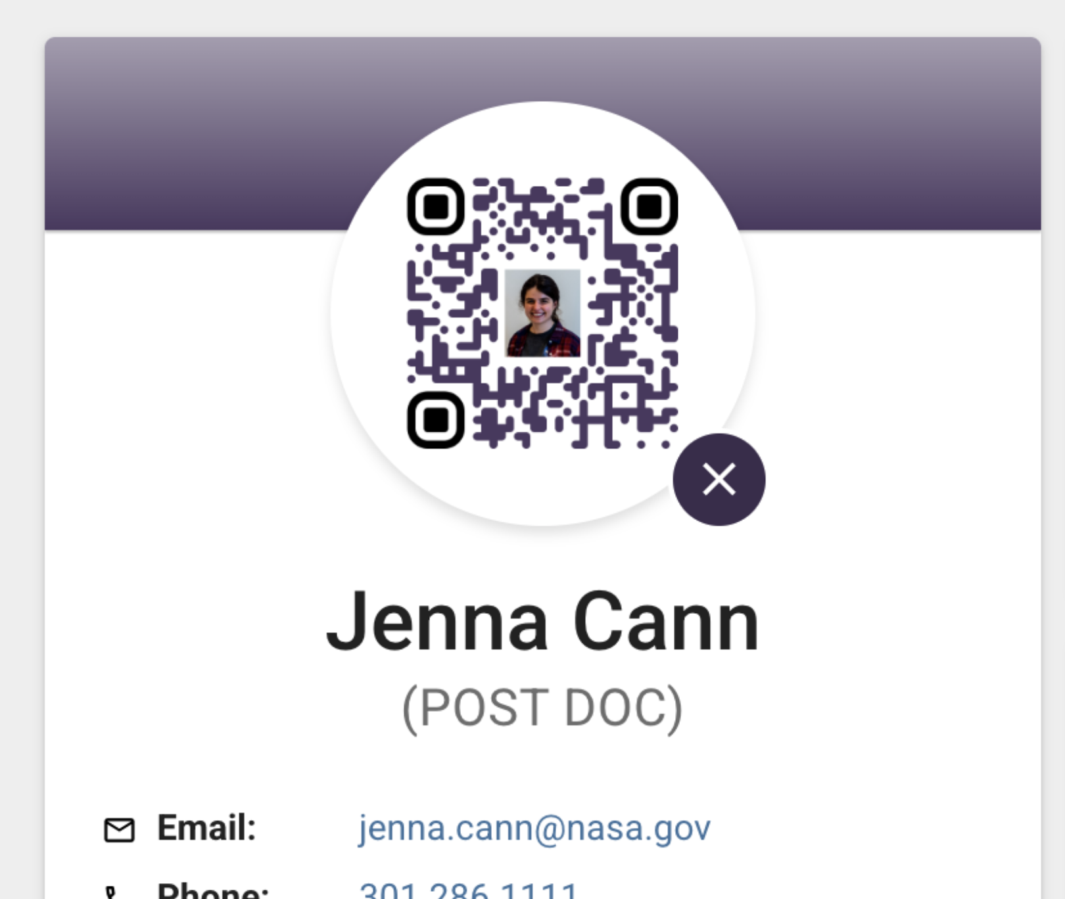

* You can also add “Roles” to your bio. This adds a button under your bio that show what you’re working on. This can be found by going to “Edit Identity” then scroll to “Roles” – there will be a default role that was entered into the system

* Note, you’ll need to provide some sort of role under the mission/project you chose, but you only need to add one of the three options (Existing Key Role, Existing Non-Key Role, Add a new Non-Key role), not all three.